

Action for Race Equality Job Pack

All you need to know about working at Action for Race Equality

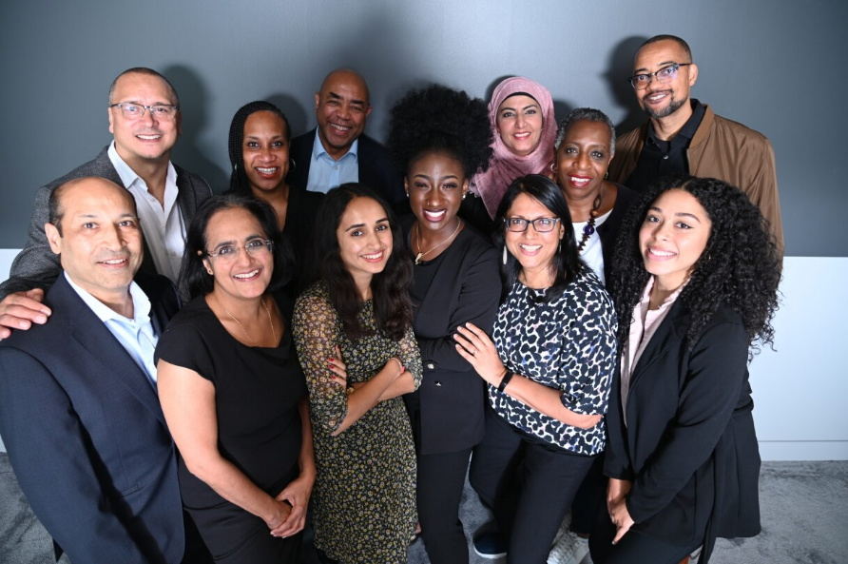

Find us at www.actionforraceequality.org.uk and search Action for Race Equality on LinkedIn.

Introduction
We are delighted you are considering applying for a role at Action for Race Equality (ARE).
We are a small, dedicated team working with volunteers, consultants and partners to deliver a wide range of programmes that align with our mission. We are looking for an enthusiastic person to join our team; someone committed to tackling race inequalities and who wants to work with diverse people to make a difference.
This information pack contains important information about ARE and the specific role you will be applying for. Please read it carefully.

About Action for Race Equality
ARE is a national race equality charity and we have been influencing policy and running programmes since 1991.
Our mission: To end race inequality
How we work: ARE champions equity, inclusion and challenges racism. We work collaboratively to support, empower and inspire young people and strengthen civil society organisations that support them. We use our national voice to influence race equity in education, employment, enterprise and the criminal justice system.

Our values:
Responsive
We listen, we observe, we learn and if we need to change what we do and how we do it, we will.
Inclusive
We engage across communities, sectors and generations, listening and responding, respecting diverse views, issues and needs.
Collaborative
We work with partners and stakeholders to strengthen our intersectional approach.
Leading by practice
We are anti-racist and lead by example. We believe in and deliver projects and activities based on an anti-racist and anti-discrimination agenda.


“Every role at ARE is critical to our mission to end race inequality, including this role. ARE is an inclusive employer and keen to attract diverse talent”. Jeremy Crook OBE, ARE Chief Executive

Role Description
Senior Assistant to Leadership Team
Salary range: £35k per annum
Pension: Employer pension contribution 8%
Annual leave: 28 days a year, plus England bank holidays
Hours: 35 hours per week
Location: Hybrid: 3 days in Kings Cross office and 2 days working from home
Duration: 2-year fixed-term contract
Reports to: SLT (Work Area Leads) and Head of Education and Youth Programme (Line Manager)

About ARE
ARE’s Senior Leadership Team are a busy hands on team and require efficient and robust support to ensure they can carry out their roles effectively. We have an engaged Board of Trustees who steer the organisation and are key stakeholders of ARE.
To support the work of our Senior Leadership Team (SLT) consisting of ARE’s Chief Executive, Deputy Chief Exec and Programme Director, we are seeking a highly organised and proactive administration professional who will be responsible for the day to day running of a dynamic and supportive business support and governance service, with an integral role in shaping and implementing improvements in line with our strategic goals. You will be a team player who supports the values of our organisation and is committed to our overall aims.
We are looking for someone who can provide comprehensive support with excellent communication and organisational skills, both written and verbal and who can built relationships with all key stakeholders, both internal and external. You will be able to manage competing demands, have a keen eye for detail and the ability to handle confidential information with absolute discretion.

Job Description

Key tasks and responsibilities

Personal Administration Support:
- Manage the diaries for SLT where required, particularly the Chief Executive, optimising the efficient use of time and resources through effective planning and ‘gatekeeping’ in a relational style that represents the charity’s values.
- Ensure all necessary briefing papers and documents are compiled for the SLT/Chief Executive in good time in advance of meetings.
- Manage a broad range of administrative tasks to facilitate the Chief Executive's leadership and line management. This might involve arranging Chief Executive’s line management supervisions and appraisals for senior staff, special projects, document design, report preparation, correspondence, maintaining contact lists, travel arrangements, and managing expenses.
- Prepare and present excellent PowerPoint and other Presentations for internal and external audiences, e.g., meetings with funders, employers, trustees and other key stakeholders.
- Assist in organising high-level events on behalf of the Chief Executive and wider SLT. This may include parliamentary receptions or other significant gatherings.

Governance Support:
- Co-ordinate and attend Trustees’ meetings, including arranging dates, preparing papers in advance, taking and sending out minutes.
- Update the SharePoint extranet site for Trustees and Governance
- Administer meetings, Fortnightly Senior Leadership meetings and others as they arise
- Oversee the log of ARE policies to ensure they are reviewed and updated as necessary
- Support with various ad hoc projects to enable robust organisational governance
- Provide administrative support to the wider senior leadership team

Other:
- Coordinate cross -cutting tasks such as preparation of the Annual Report and ARE Away Days.
- Provide HR administrative support to SLT when required.
- Collaborate with other ARE colleagues on projects where appropriate and contribute to the development of ARE as an organisation overall.
- Help to identify and support your own continual professional development and cooperate with performance appraisals.
- Adhere to and implement policies, including Equity, Diversity and Inclusion and Health and Safety.
- Undertake any roles or tasks that are consistent with the level of this post or that fall within the scope of the role thereby ensuring that the overall business and operational priorities of ARE are delivered in a timely and effective manner.

Person specification
The successful candidate will have demonstrable experience of providing administrative and senior assistant support to senior staff members and have experience of providing governance support at senior level board meetings.

Experience:
- Proven experience as a senior and/or executive assistant or other relevant administrative support experience
- Extensive experience in providing high-level administrative support to SMEs, charities, or similar organisations.
- Experience of producing accurate meeting minutes in a timely manner

Qualifications:
- Level 3 (e.g. A levels) or above

Skills
- Highly organised with an ability to prioritise, work under pressure and deliver against set targets to agreed deadlines.
- Self-sufficient with sound judgement and decision-making skills.
- Excellent verbal and written communication skills and strong interpersonal skills.
- Thoroughness, accuracy and attention to detail.
- Proven IT skills including Microsoft 365
- Ability to work across organisational boundaries and develop constructive relationships with key stakeholders

Knowledge:
- Knowledge of systemic issues facing children and young people aged 10-30 from Black, Asian and mixed heritage backgrounds.
- The role played by civil society Black and Asian led service providers in strengthening communities and supporting young people.

Personal qualities:
- The ability to manage work and time effectively, including the management of competing priorities.
- Ability to work on own initiative and as part of a team.
- Pro-active approach and skill in creative problem solving.
- Flexible and adaptable with a can-do attitude.

Confidentiality
All employees must respect at all times the confidentiality of the organisation both internally and externally.

Being part of the Team
Alongside our values, we expect everyone to display the behaviours needed to
contribute to our vision and purpose. In return, we seek to offer an inclusive,
rewarding, and collaborative environment with several benefits.

Stay and grow
- 28 days annual leave, plus 8 bank holidays per year
- Mid and annual performance review with development plans
- 8% Employer pension contribution scheme
- Annual individual Continuing Professional Development budget
- Monthly all-staff training and learning sessions
- Manage your attendance, expenses and development via our easy-to-use online Bright HR system and app

Keeping healthy
- Employee assistance programme
- Mental health and wellbeing support
- Glasses eye test cost reimbursed
- Working from home equipment budget to work safely
- Office closure between Christmas and New Year
- Discounts for services and products via Bright HR system

Great environment
- Hybrid working 50% of the working week
- Team building sessions throughout the year
- Opportunity to engage with Board of Trustees

How to apply
To apply for this post, download the Application Form.
Please ensure you also complete our Recruitment Diversity Monitoring Form.

Please email your completed application forms to: Deputy Chief Executive
Indra@actionforraceequality.org.uk

Recruitment timetable
Deadline for applications:
Friday 14th August at 5pm
Interviews to be held on:
Week commencing 24th August
Decision made by week:
Friday 4th September

We want you to have every opportunity to demonstrate your skills, ability and potential; please contact us if you require any assistance or adjustment so that we can help with making the application process work for you.
For any questions or to arrange an informal chat about this role, email Indra Nauth, ARE Deputy Executive at Indra@actionforraceequality.org.uk

Equal opportunities matter
Action for Race Equality is committed to providing equal opportunities for everyone regardless of their background. We acknowledge that people from certain backgrounds are under-represented in policy making and research and we’re committed to doing what we can to improve this.

We are particularly keen to receive applications from Black, Asian and minority ethnic people; people with disabilities and people who identify as being LGBTQ+. We guarantee to interview all disabled applicants who meet the Person Specification criteria for the vacancy. We make use
of positive action to select between candidates of equal merit as a way to address under-representation in our workforce.

We are also aware that many highly-capable prospective candidates nonetheless rule themselves out of work in policy development because they underestimate their own ability to do the role. With this in mind, we strongly encourage applications from anyone who is prepared to learn and grow on the job and would like to stress that past experience of working in think tanks is not required.

If you would like to discuss your application, or have any queries about our work, please contact hello@actionforraceequality.org.uk.

We look forward to hearing from you.

