

Action for Race Equality Job Pack

All you need to know about working at Action for Race Equality
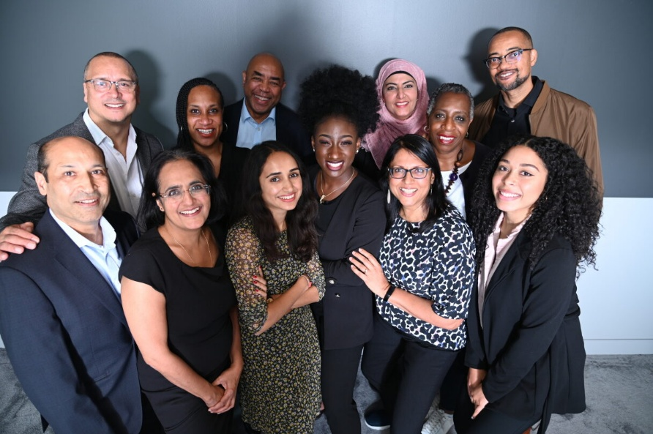

Find us at www.actionforraceequality.org.uk and search Action for Race Equality on LinkedIn.

Introduction
We are delighted you are considering applying for a role at Action for Race Equality (ARE). We are a small, dedicated team working with volunteers, consultants and partners to deliver a wide range of programmes that align with our mission. We are looking for an enthusiastic person to join our team; someone committed to tackling race inequalities and who wants to work with diverse people to make a difference. This information pack contains important information about ARE and the specific role you will be applying for. Please read it carefully.

About Action for Race Equality
ARE is a national race equality charity and we have been influencing policy and running programmes since 1991.
Our mission: To end race inequality for Black, Asian and Mixed heritage young people.
How we work: ARE champions equity, inclusion and challenges racism. We work collaboratively to support, empower and inspire young people and strengthen civil society organisations that support them. We use our national voice to influence race equity in education, employment, enterprise and the criminal justice system.

Our values:
Responsive We listen, we observe, we learn and if we need to change what we do and how we do it, we will.
Inclusive We engage across communities, sectors and generations, listening and responding, respecting diverse views, issues and needs.
Collaborative We work with partners and stakeholders to strengthen our intersectional approach.
Leading by practice We are anti-racist and lead by example. We believe in and deliver projects and activities based on an anti-racist and anti-discrimination agenda.



“Every role at ARE is critical to our mission to end race inequality, including this role. ARE is an inclusive employer and keen to attract diverse talent”. Jeremy Crook OBE, ARE Chief Executive

Role Description
Job title: APA Development Officer
Salary: £30k per annum
Hours: 35 hours per week
Benefits: Employer pension contribution 8%
Type of post: Secondment will be considered
Location: Hybrid working 3 days in Kings Cross or Brixton office and 2 days working from home
Fixed contract: Initial 12 months
Annual leave: 28 days a year, plus England bank holidays
Accountable to: ARE Chief Executive (line manager) & APA Steering Group Chair

About ARE
This is an excellent opportunity to work for a valued national charity.
We are seeking a highly organised and proactive administration professional who will be responsible for the day to day running of a dynamic and supportive business support and governance service, with an integral role in shaping and implementing improvements in line with our strategic goals. You will be a team player who supports the values of our organisation and is committed to our overall aims.

About APA
The APA is a progressive, Black-led police accountability initiative covering England and Wales that seeks to transform the relationship with the police and develop community led strategies for reducing violence.
Since the APA’s successful launch in July 2023 it has hosted national events; responded to government consultations; started to form partnerships with Black organisations in London, Birmingham, Cardiff and Manchester; and is making a robust contribution to the NPCC’s Police Race Action Plan. The Alliance aims to have four city-wide community informed charters to inform the production of a national charters on police accountability and violence reduction.
The APA places high importance on taking an intersectional approach to everything we do and we are determined to draw on the knowledge, skills, commitment and lived experience of young people, men and women, disabled people, and LGBT people from African and Caribbean backgrounds. Everyone’s voice matters.
APA is supported by a National Steering Group (NSG) comprised of leading, Black-led organisations including Black Equity Organisation, Black Men 4 Change, Blacsox, UK Black Pride, National and London Black Police Associations. Action for Race Equality is the accountable body for funding and employing staff.
The APA is seeking to employ a Development Officer to help drive the initiative forward at the national and cities level and provide secretariat support to the National Steering Group. The successful candidate will need to be a self-starter, organised, committed to race equity and passionate about issues the APA and its partners are tackling in England and Wales. The post-holder will be expected to travel to partner cities (Birmingham, Cardiff, Manchester).

Job Description

Key tasks and responsibilities:

Key priorities:
- To build good relationships with APA stakeholders at city and national level to ensure their input into APA’s charter processes and campaigns.
- Support APA public campaigns by providing insights and contributing to communication materials.
- Liaise with funders and draft and submit high quality funding proposals.

Ongoing priorities:
- To provide secretariat support for the National APA Steering Group.
- To ensure information is shared both ways between APA city and national partners.
- Keep up to date with developments in policing and race equality.
- Represent APA on appropriate external meetings and events.
- Help to identify and support your own continual professional development and cooperate with performance appraisals.
- Contribute to the success of ARE by participating in performance management arrangements, fundraising and research proposals and by applying the principles and practices associated with equality in employment, equality in service delivery and health & safety in the workplace.
- Undertake any roles or tasks that are consistent with the level of this post or that fall within the scope of the role thereby ensuring that the overall business and operational priorities of ARE are delivered in a timely and effective manner.

Person specification
The successful candidate will have experience supporting diverse stakeholders and be committed to addressing race inequalities in policing and violence reduction. They should be comfortable communicating to general and specific audiences and have excellent writing and presentation skills.

The post holder will be actively interested in what is happening in policing, Black organisation empowerment, local accountability and the wider criminal justice system and be alert to opportunities to work collaboratively with colleagues to advance APA’s aims.

Experience:
- Experience of managing diverse stakeholders and working with Black-led organisations.

Qualifications:
- Relevant degree level qualification or equivalent professional and/or lived experience.

Skills
- Good written and oral communication skills.
- Experience of project management.
- Ability to work across organisational boundaries and develop constructive relationships with key stakeholders.
- Effective interpersonal skills including influence, persuasion, assertiveness, and sensitivity.

Knowledge:
- Knowledge of the systemic issues affecting Black and Mixed heritage communities.
- Awareness of the role of government and various government agencies in shaping policies and programmes affecting the criminal justice system.
- Awareness of the diverse role Black-led organisations can play in improving outcomes.

Personal qualities:
- Ability to work on own initiative and as part of a team.
- Highly motivated with the ability to motivate others.
- Able to prioritise workloads and complete agreed programme outputs.
- Pro-active approach and skill in creative problem solving.
- Proven IT skills including Microsoft Office.

Confidentiality
- All employees must respect at all times the confidentiality of the organisation both internally and externally.

Basis of contract
- The post is funded by Barrow Cadbury Trust, Esmee Fairbairn Foundation and Clothworkers’ Foundation initially for 12 months.

Being part of the Team
Alongside our values, we expect everyone to display the behaviours needed to
contribute to our vision and purpose. In return, we seek to offer an inclusive,
rewarding, and collaborative environment with several benefits.

Professional Development
- Help to identify and support your own continual professional development and cooperate with performance appraisals
- Contribute to the success of ARE by participating in performance management arrangements, fundraising and research proposals and by applying the principles and practices associated with equality in employment, equality in service delivery and health & safety in the workplace.

Stay and grow
- 28 days annual leave, plus 8 bank holidays per year (pro-rata)
- Mid and annual performance review with development plans
- 8% Employer pension contribution scheme
- Annual individual Continuing Professional Development budget
- Monthly all-staff training and learning sessions
- Manage your attendance, expenses and development via our easy-to-use online Bright HR system and app

Keeping healthy
- Employee assistance programme
- Mental health and wellbeing support including a trained mental health first-aider within the team
- Working from home equipment budget to work safely
- Office closure between Christmas and New Year
- Discounts for services and products via Bright HR system

Great environment
- Hybrid working 50% of the working week
- Team building sessions throughout the year
- Opportunity to engage with Board of Trustees

How to apply
To apply for this post, download the Application Form.
Please ensure you also complete our Recruitment Diversity Monitoring Form.

Please email your completed application forms to: Deputy Chief Executive
Indra@actionforraceequality.org.uk

Recruitment timetable
Deadline for applications: 23rd January 2026

Interviews to be held on: w/c 2nd February 2026

Decision made by week: 20th February 2026

We want you to have every opportunity to demonstrate your skills, ability and potential; please contact us if you require any assistance or adjustment so that we can help with making the application process work for you.

For any questions or to arrange an informal chat about this role,
email: ARE Chief Executive jeremy@actionforraceequality.org.uk or APA Steering Group Chair lee-jasper@live.com

Equal opportunities matter
Action for Race Equality is committed to providing equal opportunities for everyone regardless of their background. We acknowledge that people from certain backgrounds are under-represented in policy making and research and we’re committed to doing what we can to improve this.

We are particularly keen to receive applications from Black, Asian and minority ethnic people; people with disabilities and people who identify as being LGBTQ+. We guarantee to interview all disabled applicants who meet the Person Specification criteria for the vacancy. We make use
of positive action to select between candidates of equal merit as a way to address under-representation in our workforce.

We are also aware that many highly-capable prospective candidates nonetheless rule themselves out of work in policy development because they underestimate their own ability to do the role. With this in mind, we strongly encourage applications from anyone who is prepared to learn and grow on the job and would like to stress that past experience of working in think tanks is not required.

If you would like to discuss your application, or have any queries about our work, please contact hello@actionforraceequality.org.uk.

We look forward to hearing from you.

