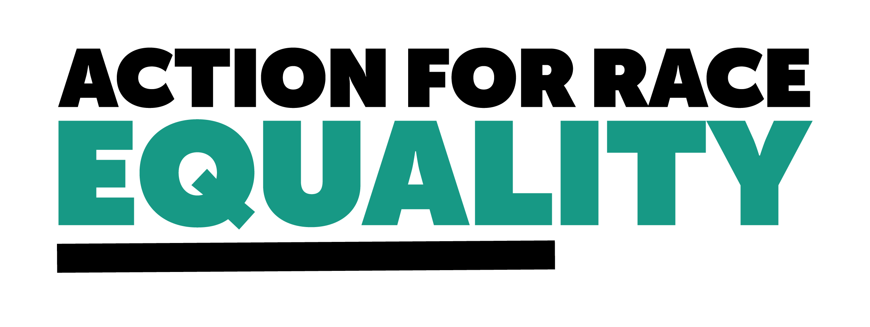

**Call for Evidence response: Open Justice, the way forward**

**About Action for Race Equality**

Action for Race Equality (ARE) was founded in 1991, and over the last 30+ years we have worked to champion fairness, challenge race inequality and pioneer innovative solutions to empower young people across education, employment, and criminal justice.

ARE believes that equal treatment under the law is a fundamental aspect of the criminal justice system that is consistently denied to young people who are Black, Asian or of Mixed Heritage. Our vision is a criminal justice system that delivers fair outcomes for all. Our purpose is to help those involved in the development and delivery of criminal justice practice and policy to create a system free from unfair outcomes for Black and Minority Ethnic people. We believe that action must be taken to address the issues that lead to unjust experiences and outcomes for Black and Minority Ethnic people in the criminal justice system.

We welcome the government’s decision to hold a public consultation on open justice. Our submission to this consultation will cover serious issues regarding evidence of institutional racism within the judiciary, and how open justice may be utilised to begin dismantling structural issues which contribute to harsher outcomes for Black, Asian, and mixed heritage people.

**Evidence of Institutional Racism in the judiciary**

The judicial system operates on the core principle that the law is impartial. For Black, Asian, and mixed heritage people, that fundamental impartiality is not a given. At every stage of the criminal justice system, the experiences, and outcomes of a Black, Asian, or mixed heritage person are disproportionately worse. Over a quarter (27%) of the prison population are from an ethnic minority background. 53% of the children and young people in youth custody are from a minority ethnic background. 17% of the prison population is Muslim, compared to just 6% of the general population. From over-policing to [longer sentences for the same crimes](https://assets.publishing.service.gov.uk/government/uploads/system/uploads/attachment_data/file/643001/lammy-review-final-report.pdf), the evidence of a racially discriminatory system perpetuates across the entire justice system.

A report published last year, [Racial Bias and the Bench](https://documents.manchester.ac.uk/display.aspx?DocID=64125), found the judiciary to be institutionally racist. As part of the report, a survey of legal professionals was conducted and over 95% of respondents said that they believe racial bias plays some role in the processes and/or outcomes of the justice system. Over half of those professionals reported witnessing at least one judge acting in a racially biased way towards a defendant. Despite the significant evidence of racism within the judiciary, the report authors found only one published Judicial Conduct Investigations Office decision in which racism was found against a judge since 2020.

**Open Justice**

Open justice can, in principle, better enable the public to witness when racial bias occurs within the justice process and subsequently allow the public to hold the judiciary to account.

When the initiative was first introduced it intended to allow anyone to observe sentencing across courts in England and Wales. Additions that have been made since the last consultation in 2012 are particularly beneficial for supporting the public in exercising its ability to independently observe the judicial process. In particular, the introduction of a streamlined listings service increased access to court and tribunal documents is particularly helpful.

**Independent discretion**

However, there are some concerns that these initiatives often rely too much on a judge’s discretion over whether access will be allowed. For example, it is up to the judge to decide if their sentencing remarks will be published. Sentencing decisions need greater scrutiny, and while this would take additional resource to publish, we believe it would make for an important addition to the evidence base which would allow better scrutiny.

The judiciary and other legal professionals are not required to take training on antiracism, cultural competency, or other relevant training programmes. There is disproportionate representation of judges from Black, Asian, and mixed heritage backgrounds, and the Judicial Diversity and Inclusion Strategy makes no reference to racial bias or racism. There is a concern for us that without the proper structures in place to increase the ability to understand racial bias amongst judicial staff, then racial bias will be allowed to persist. To navigate this issue in the meantime, a judge should not have sole discretion over the publication of certain details, such as sentencing remarks, and instead we would suggest a panel model which could make this decision.

**Data**

The efforts that have been made to facilitate access to data are welcomed, but we would like to see some additional changes to firstly improve the data that is collected on the judiciary, and in how requests for data are handled.

It is particularly important that demographic characteristics – namely ethnicity, age, gender, etc – are collected in a uniform way across the whole judicial system to allow for helpful comparisons between demographics. We support the recommendation made by Lammy that it should be possible to view sentences for individual offences at individual courts, broken down by demographic characteristics to allow for this comparison.

Currently, the process to access certain types of data is quite difficult. By requiring an individual to make an application for certain data, and sometimes requiring a fee for that data, there is a restriction on holding the judiciary to account. Some individuals

May find making this application difficult, as they may not know exactly what data they are seeking for, and so the process could become prohibitive. We understand that not all data can be published to everyone, but we would support streamlining the application process through the publication of easy-to-read guides on what types of data are available and how to apply to access this data. This could be considered under the Public legal education initiative.

**Public Legal Education**

The confidence of the judicial system amongst Black, Asian, and mixed heritage communities is at an all-time low. Just a few months ago, Baroness Louise Casey found in her landmark review that institutional racism, sexism, and homophobia has continued to persist, and even worsen, in the Metropolitan Police service. The Casey Review confirmed what Black and Brown communities in London have always known – policing is broken. Importantly, this mistrust and disbelief in policing extends to all aspects of the justice system. There is significant evidence that the criminal justice system is institutionally racist, and we know that there is an opportunity for the government to recognise this and begin to rebuild the system in a way that dismantles the structures that have created harsher outcomes for Black, Asian, and mixed heritage people.

Public legal Education could be utilised as a tool to begin addressing racism across the judiciary. Through improved education about the legal system in schools and to the wider public. We would also encourage more official resource and materials that specifically consider the issue of race in relation to the justice system.

The open justice initiative would do well to consider race in relation to all aspects of the initiative, and we would welcome any conversations that colleagues within the Ministry of Justice would wish to have with Action for Race Equality regarding this.

For more information, contact Meka Beresford, Head of Policy, via [meka@actionforraceequality.org.uk](mailto:meka@actionforraceequality.org.uk)