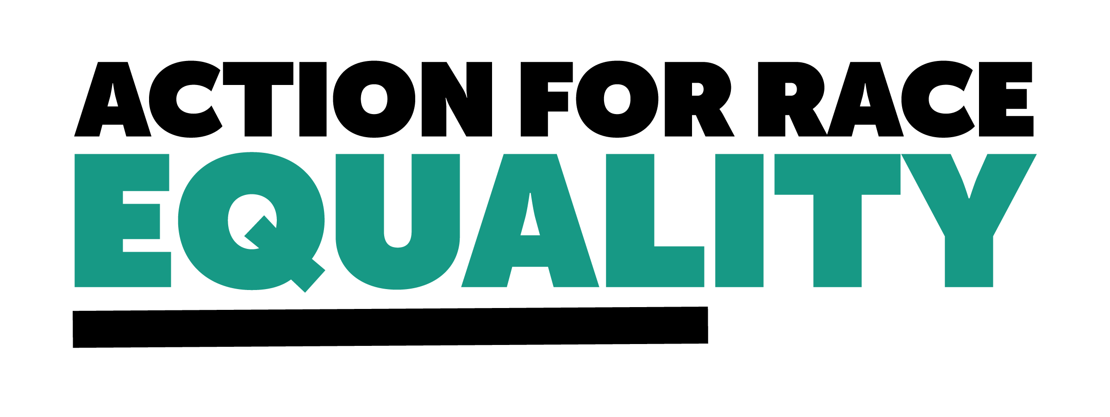

**Draft Community Scrutiny Framework: National guidance for community scrutiny panels**

**About Action for Race Equality**

Action for Race Equality (ARE) was founded in 1991, and over the last 30+ years we have worked to champion fairness, challenge race inequality and pioneer innovative solutions to empower young people across education, employment, and criminal justice.

ARE believes that equal treatment under the law is a fundamental aspect of the criminal justice system that is consistently denied to young people who are Black, Asian or of Mixed Heritage. Our vision is a criminal justice system that delivers fair outcomes for all. Our purpose is to help those involved in the development and delivery of criminal justice practice and policy to create a system free from unfair outcomes for Black and Minority Ethnic people. We believe that action must be taken to address the issues that lead to unjust experiences and outcomes for Black and Minority Ethnic people in the criminal justice system.

We welcome the government’s decision to hold a public consultation on Community Scrutiny Panels (CSPs). Action for Race Equality is available to further discuss our feedback laid out here.   
  
**1. Do you believe this draft framework and terms of reference for community scrutiny of police powers achieves the aims set out in 'Inclusive Britain' Action 10**  
  
To an extent.   
  
This framework is a good foundational document that provides clear terms of reference for community scrutiny panels. The key principles are good, and we welcome the clarity it will provide to existing panels and new panels that will be established down the line.   
  
However, there is a concern that because the framework does not have statutory basis nor does it impose any legal duties, it will not resolve some existing issues with community scrutiny panels. In particular, we are concerned about the current poor resourcing of community scrutiny panels, which in turn causes an inconsistency in the effectiveness of CSPs across policing.  
  
Action 10 calls for effective local scrutiny. Without proper resourcing or clear guidance on resourcing and remuneration for members, community scrutiny panels could remain inconsistent in terms of effectiveness.  
  
This issue could be remedied with the inclusion of a section under training and resources or governance that provides clear guidelines on what suitable resourcing would look like, including a guide on the number of meetings/hours of convening for the panel, number of cases to scrutinise per month/annum, the rate at which CSP members should be made.  
  
**2. Does the draft framework strike the right balance between setting out key principles while allowing scope for flexibility in local scrutiny arrangements?**  
  
Yes.  
  
**3. Is the draft framework clear and accessible for its intended audiences, including members and chairs of community scrutiny panels?**  
  
To an extent. In certain places, unnecessarily complex language is used such as ‘diverse cadre’ in section 3.8. We would encourage using as simple and straightforward language as possible.   
  
The framework is quite lengthy, and the production of a simple overview for referral purposes may be beneficial.   
  
Regarding the section on safeguarding, there were some instances where further explanation would be beneficial. For instance, section 4.13 refers to sharing cases of intrusive use of police powers such as strip search with community scrutiny panels ‘as appropriate’. The following sections provide some clarity about what cases should and should not be shared with CSPs, but there is a concern that ‘as appropriate’ could be interpreted in a way that limits the number of cases shared with CSPs on the basis of content.   
  
**4. Are there any relevant considerations the draft framework has omitted or not sufficiently addressed?**  
  
We feel that the framework could be more specific regarding the role that CSPs will have in repairing some of the trust between communities and policing, especially between Black, Asian, and ethnic minority communities. We appreciate that the framework has drawn on guidance laid out in the Race Action Plan, but the panel could be more specific about the racialised nature of misuse of police powers and how this could be considered by CSPs.   
  
We would appreciate additional information being published about the consultation process that took place in order to produce the draft framework.  
  
We would like further clarification on how this framework will be linked to the Police Race Action Plan and whether the framework will be statutorily mandated.  
  
**5. Do you have any other feedback on the draft framework and terms of reference?**  
  
In the draft framework, section 3.15 states that a CSP should be reflective of the local demographic. We welcome this step toward ensuring that CSPs are representative of the demographic. However, we feel this could go further to encourage a more inclusive and diverse representation on CSPs, in particular regarding race. We know that policing disproportionately affects Black, Asian, and ethnic minority communities. Therefore, the panels could favour including more panel members from Black, Asian, or ethnic minority backgrounds, even if this is not proportional to the local demographic. This would be supported by guidance in the Race Action Plan, which describes scrutiny panels as a tool to enable Black communities to have a voice and influence policing governance.   
  
Section 3.7 allows for PCCs and the police to assist in the selection of panel members, without prejudicing panel independence. We feel that this should be adjusted, so that PCCs and police only have the opportunity to recommend members for panels, and not prevent individuals from becoming panel members without good reason.   
  
Whilst local scrutiny panels are important mechanisms, they are notoriously inconsistent across the country, poorly resourced, not seen as independent from the police and do not include enough representatives from those communities who are most targeted by practices such as Stop and Search and Use of Force. This framework will be a beneficial and important tool in beginning to standardise the way in which CSPs operate, and we are hopeful that with proper resourcing, transparency, and collaboration, CSPs will become a more meaningful way in which scrutiny can occur.   
  
For more information, contact Meka Beresford, Head of Policy, via [meka@actionforraceequality.org.uk](mailto:meka@actionforraceequality.org.uk)