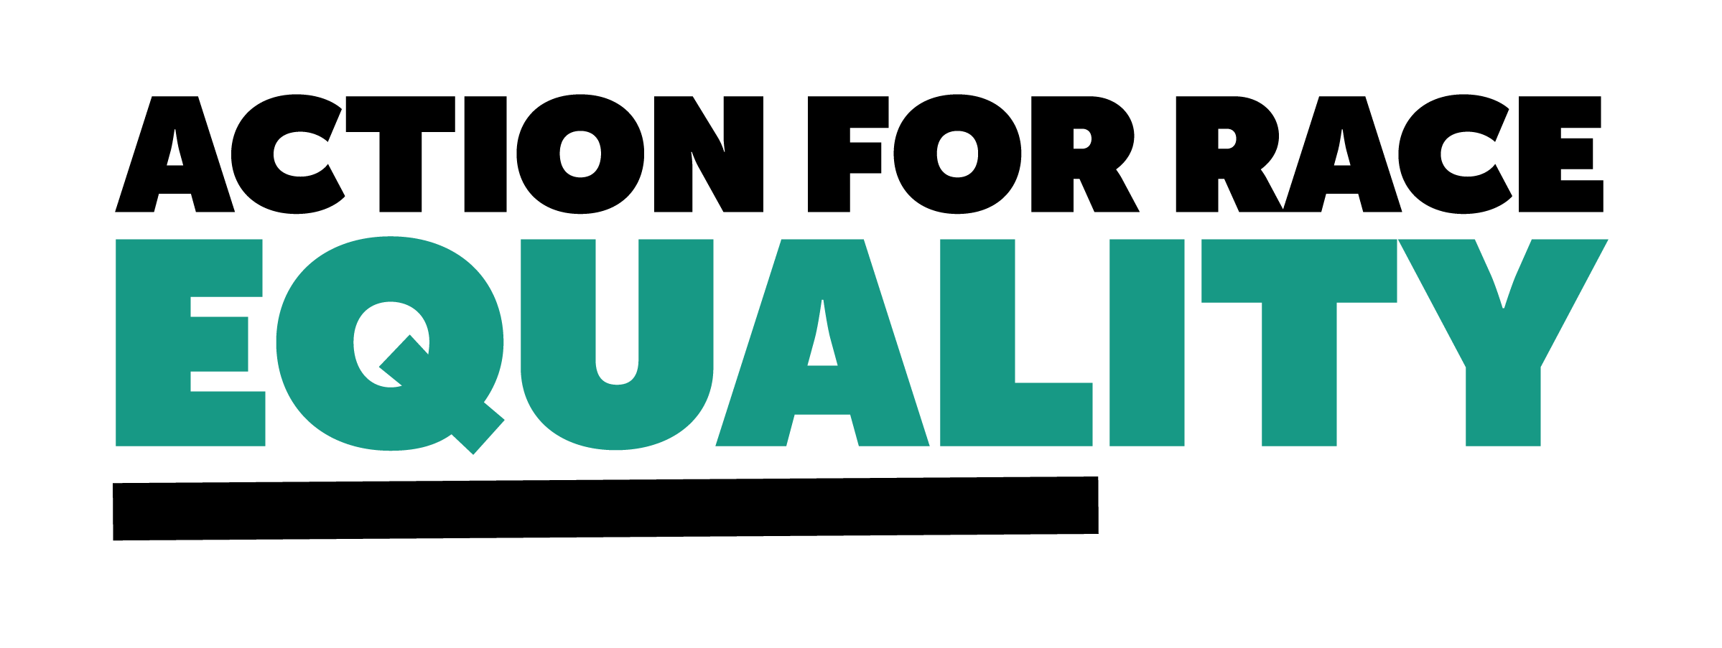

**Diversionary and Community Cautions: Draft Code of Practice Consultation**

**About Action for Race Equality**

Action for Race Equality (ARE) was founded in 1991, and over the last 30+ years we have worked to champion fairness, challenge race inequality and pioneer innovative solutions to empower young people across education, employment, and criminal justice.

ARE believes that equal treatment under the law is a fundamental aspect of the criminal justice system that is consistently denied to young people who are Black, Asian or of Mixed Heritage. Our vision is a criminal justice system that delivers fair outcomes for all. Our purpose is to help those involved in the development and delivery of criminal justice practice and policy to create a system free from unfair outcomes for Black and Minority Ethnic people. We believe that action must be taken to address the issues that lead to unjust experiences and outcomes for Black and Minority Ethnic people in the criminal justice system.

We welcome the government’s decision to hold a public consultation on the draft code of practice for Diversionary and Community cautions. In England and Wales, Black, Asian, and Mixed Heritage people are disproportionately over-represented within the criminal justice system. Ethnic minority people, and particularly Black people, are frequently over-policed, and once they come into contact with the criminal justice system, they experience harsher outcomes. This includes a higher likelihood of being imprisoned, with Black Caribbean, mixed white and Black Caribbean and mixed white and Black African people [facing a charge rate nearly 12% higher](https://www.cps.gov.uk/publication/cps-charging-decisions-examining-demographic-disparities-outcomes-our-decision-making) than white counterparts for similar offences. Black, Asian, and Mixed Heritage people also receive longer sentences - [in 2020 the average custodial sentence length](https://assets.publishing.service.gov.uk/government/uploads/system/uploads/attachment_data/file/1037903/Statistics_on_Ethnicity_and_the_Criminal_Justice_Sysytem_2020.pdf) for white offenders was 19.6 months, for black offenders it was 26.8 months.

The impact that a custodial sentence can have on an individual is life changing. The new code of practice for diversionary and community cautions offers the chance to improve the way in which we divert individuals away from the criminal justice system. This is particularly important for people who are Black, Asian, or Mixed Heritage, who frequently receive less diversionary measures.

Our submission to this consultation will address the issues within the draft code of practice that may further entrench racial disparities and make suggestions as to how the code could be improved to ensure better outcomes for Black, Asian, and Mixed Heritage people and Diversionary and Community Cautions.

**What causes disparities in diversion**

One of the most significant barriers that creates a disparity in the use of diversion and community cautions or an out of court disposal is the requirement for an admission of guilt. There is a deeply entrenched, intergenerational mistrust in policing by Black, Asian, and Mixed Heritage communities. Having the requirement for an admission of guilt to be granted an OOCD or other diversionary caution is a significant blocker to ethnic minority groups given the mistrust of police. Unless that individual can be guaranteed that their admission of guilt will not later be used against them, then they will likely miss the opportunity to receive a caution. Moreover, an admission of guilt does not signify genuine remorse for actions, and it should not be perceived as such.

Another key issue which may be increasing disparities within diversion is institutional racism. Baroness Casey detailed in her review of the Metropolitan Police Service how racism perpetrated all levels of the MPS: there is disproportionate use of stop and search, use of force, and intimate strip searching of young Black people. Black, Asian, and Mixed Heritage staff are frequently undervalued, and held to higher standards. Importantly, Baroness Casey found that the Met is complacent about tackling these issues. Knowing that institutional racism has perpetrated the MPS, and other chief police staff in other forces in England and Wales including Avon and Sommerset and South Wales, there is a clear concern that officer’s own bias and racism is also impacting the use of diversionary and community cautions for Black, Asian, and Mixed Heritage people.

**Equality Impact assessment**

For both tiers of the statutory framework, the offender needs to admit guilt and agree to the particular OOCD in order for the offence to be dealt with outside the court process.As part of the Equality Impact Assessment, there is recognition of a risk that ethnic minority individuals may be less likely to receive an early intervention under an OOCD, and as such become more likely to be prosecuted, because of the requirement to admit guilt.

In order to mitigate this risk, the equality impact assessment noted an intention to rely on criminal justice system scrutiny panels as well as collaboration with the Chance to Change pilot sites. We understand that the Chance to Change pilots operate quite differently to OOCDs in terms of eligibility criteria, intervention methods, and the outcomes that are available. Without the evaluation having already been completed, there is a concern that committing to collaborate with the pilot sites to mitigate the risk of racial disparity will not have the desired effect of improving the access to diversionary cautions for Black, Asian and Mixed Heritage people. We would welcome more clarity on the timeline for this evaluation, and in particular information about what learnings will be taken from this evaluation and implemented into the code of practice to ensure that Black, Asian, and Mixed Heritage people receive more diversion outcomes.

Regarding the scrutiny panels that will be used, we understand that there is a separate consultation currently open on a draft community scrutiny framework which will determine how local scrutiny processes can be improved to help police serve communities more effectively. We hope that there will be plans to implement learnings from this consultation into this framework, as the current system of local scrutiny panels appears to have some issues with transparency and accountability.

**Suggestions**

We welcome the recognition of disparity in the current use of cautions. We would encourage the softening of the requirement of an admission of guilt and allow for increased discretion in the use of cautions that would allow for a caution to be given without the admission of guilty. This increased discretion should be closely monitored to ensure that racism or bias is not feeding into the final decision about the use of cautions.

The draft code of conduct could benefit from having additional guidance built in that gives advice on cultural competency and adapting practice to best suit individuals. This guidance could explain the barriers around OOCDs and cautions and detail the individual importance of working towards ending racial disparities. This could include information about the mistrust felt between Black, Asian, and Mixed Heritage communities of the police. We understand that there is a certain amount of training police go through regarding this, but we feel it is helpful and beneficial to provide reminders at critical times to begin dismantling the institutional racism that was identified by Baroness Casey.

Regarding the interventions that are made as part of the caution, we were pleased to see the emphasis placed on the victim’s point of view and needs regarding the interventions. We would encourage an emphasis on making sure that these interventions are also fit for purpose in a culturally competent way – this could be achieved through the guidance recommending relationship building with local Black and Asian led organisations, who are well placed to identify positive interventions and programmes which can have additional positive outcomes for their communities.

Finally, we would encourage the increased monitoring of the success of cautions for the recipients. Understanding which interventions have been successful for Black, Asian, and Mixed Heritage people will be particularly important for ensuring successful cautions in the future.

For more information, contact Meka Beresford, Head of Policy, via [meka@actionforraceequality.org.uk](mailto:meka@actionforraceequality.org.uk)