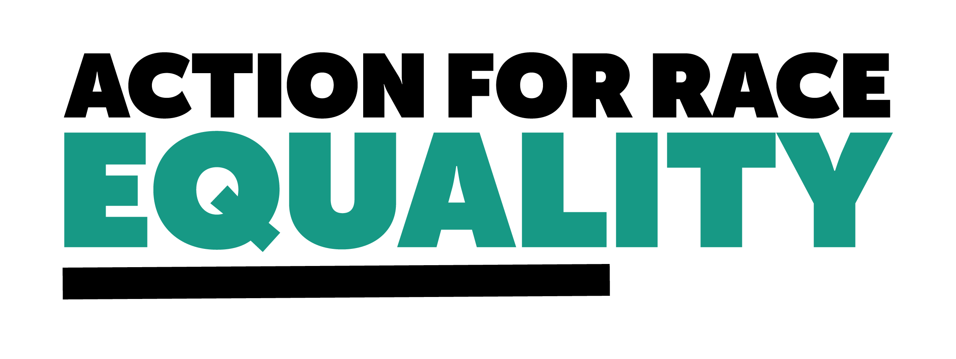

**Consultation on youth remand funding arrangements**

**About Action for Race Equality**

Action for Race Equality (ARE) was founded in 1991, and over the last 30+ years we have worked to champion fairness, challenge race inequality and pioneer innovative solutions to empower young people across education, employment, and criminal justice.

ARE believes that equal treatment under the law is a fundamental aspect of the criminal justice system that is consistently denied to young people who are Black, Asian or of Mixed Heritage. Our vision is a criminal justice system that delivers fair outcomes for all. Our purpose is to help those involved in the development and delivery of criminal justice practice and policy to create a system free from unfair outcomes for Black and Minority Ethnic people. We believe that action must be taken to address the issues that lead to unjust experiences and outcomes for Black and Minority Ethnic people in the criminal justice system.

**1. In your opinion, has the current remand funding supported alternatives to custody?**

No - The current remand funding has not supported alternatives to custody to the extent that we would have hoped. We agree with the conclusion made in the consultation that the current remand funding has not created enough incentivisation for the creation of community alternatives to custody.  
  
**2. What type of bail with intervention or remand to local authority package do you think best meets the needs of children and protects the public? Do the community alternatives in your area meet demand?**

We would encourage the use of community alternatives to custody that are designed in a child first manner. In particular, these packages should, where possible, be bespoke to the needs of the child and be designed by those working in the local community who will have a better insight into the needs of the community. These packages should be culturally sensitive and designed in a way which addresses the harms a child may have experienced in relation to their ethnic identity.

**3. What influences the likelihood of community alternatives to custodial remand being presented to courts in your local area? Why do you think we have not seen a significant increase in the use of alternatives to custody?**

We do not work in a local area, but have a national perspective on youth remand. One of the significant barriers that has prevented the significant increase in the use of alternatives to custody is related to racial injustice. Often times, the use of alternatives to custody may require the young person to make an admission of guilt in some way. For young Black, Asian, or Mixed Heritage children they would frequently opt to not make this admission. There is a deeply entrenched, intergenerational mistrust in criminal justice by Black, Asian, and Mixed Heritage communities. Having the requirement for an admission of guilt is a significant blocker to ethnic minority groups given the mistrust. Unless that individual can be guaranteed that their admission of guilt will not later be used against them, then they will likely miss the opportunity to receive an alternative to custody. Moreover, an admission of guilt does not signify genuine remorse for actions, and it should not be perceived as such.

We welcome the significant improvements that have been made to reduce the number of children and young people entering the custodial system. However, there is a concern that while the numbers have decreased, the racial disparities within these numbers has continued to persist. The ethnic disparities in the population of children remanded to custody is incredibly stark and this should be addresses in a future funding model.

**4. What are your thoughts on the funding model remaining the same (Option 1)?**

We do not believe the funding model should remain the same.

**5. How do you think a regional model (Option 2a) could affect the availability of community alternatives to custody?**

A regional model could be beneficial. We would welcome the additional spending power this could provide to local authorities and the potential for additional investment into alternatives to custody. An evaluation of the pilot in Greater Manchester would be beneficial to consider before pursuing this option. We would be concerned about children or young people being moved out of their local area as detailed in the consultation, and so if this model was pursued additional safeguarding and thinking would need to be implemented to prevent this.

**6. How easy or difficult would it be for your region to adopt a regional model (Option 2a)?**

N/a

**7. Do you think our aims would be better met by amending the funding mechanism (Option 2b & 2c)? What are your thoughts on consolidating the funding relating to LAC status into wider funding for children’s services?**

We think 2b could be a beneficial amendment. 2c could be beneficial, but we would be hesitant if alternatives to custody weren't properly ring fenced in the funding.

**8. Do you think that enabling funding via bids would affect the availability of alternatives to custody (Option 3)?**

This may be a good option but we would be concerned about the denial of funding bids and what criteria would be created to determine this bid system.

**9. Do you think that a central approach could support alternatives to custody (Option 4)?**

This central approach might work but it would require additional input from local services to ensure that children and young person's needs are properly met in an informed way. We would also be concerned about the geographic spread and the multi-agency working in this instance.

**10. Which option do you think would best meet our objectives (on page 21)?**

Ideally a combination of these options would be beneficial, but we understand this may not be financially possible. We would encourage a regional model with the addition of central provision specifically for violent offences. Before moving to the regional model in full, it may be beneficial to first alter the formula for calculating allocations to evaluate how each area is using their funding. This evaluation could help to better inform a regional model.

**11. Do you have an alternative proposal for amending remand funding?**

No

**12. If the funding changed, what transition arrangements would be the most important to you?**

Working closely with local authorities and YOTs to inform the new funding model

**13. What do you consider to be the equalities impacts on individuals with protected characteristics as a result of the proposals? Are there any mitigations the government should consider? Are there potential positive equality outcomes the government should consider?**

The government has done well to reduce the number of young people in custody, however the racial disparity of the current youth custodial population is very concerning. Altering the current youth remand funding will be an important tool in ending these disparities. We feel this can be accomplished with increased funding for alternatives to custody which are purposefully anti-racist and designed in a culturally sensitive way. We would encourage the new remand funding model to provide additional funding for alternatives to custody which are culturally sensitive and specifically support Black, Asian and mixed Heritage children and young people.

**14. Do you have any other comments on these issues?**

We would welcome the opportunity to further discuss supporting alternatives to custody which are culturally sensitive and minimise the harm that a young person or child may experience in regards to racial injustice within the criminal justice system.